Experiment 3 – Distance, Bus and Transformer Protection

3.1 Objectives
The objectives of this laboratory exercise are:
- Study distance protection for transmission line.
- Summarize common bus faults,
- Identify methods for bus protection,
- Summarize common transformer faults,
- Identify methods for transformer protection,
- Discuss issues with the protection of transformers in power systems,
- Present combined bus and transformer protection methods.

3.2 Distance Protection
Transmission protection using over-current relays is difficult and may not be possible, even if the over-current relays are directional. In such cases a more selective relay is required. The distance relay is often the preferred solution to this problem. It meets the requirements of reliability and speed needed to protect these circuits, and for these reasons is extensively used on power system networks.

Distance protection is a non-unit type of protection and has the ability to discriminate between faults occurring in different parts of the system, depending on the impedance measured. Essentially, this involves comparing the fault current, as seen by the relay, against the voltage at the relay location to determine the impedance down the line to the fault. The main advantage of using a distance relay is that its zone of protection depends on the impedance of the protected line that is a constant virtually independent of the magnitudes of the voltage and current. Thus, the distance relay has a fixed reach, in contrast to overcurrent units where the reach varies depending on system conditions.

3.2.1 Distance relays
Distance relays can have characteristics as shown in Fig. 1. Fig. 1a shows a Zone-2 impedance characteristic with a balance point, that is, a circle, centered at the origin of an R-X diagram. If the circuit impedance falls within the circle that describes the balance point for the relay, the relay actuates and closes its output contact. If the circuit impedance is outside the circle, the relay does not operate.

Such impedance relays are not directional. Directional supervision should be added to instantaneous impedance relays. Fig. 1b shows a Zone-2 mho (offset impedance) characteristic with a balance point, that is, a circle, centered on the “line angle”. The operation is similar to the impedance relay. Mho relays are inherently directional. When applying electromechanical distance relays, the diameter of the relay balance point is located at 60° or 75°, as the angle of the diameter is not adjustable.

Fig. 1c shows a Zone-2 reactance relay characteristic with a balance point that is a straight line above, and parallel to, the R-axis. If the circuit impedance falls below the line that describes the balance point for the relay, the relay operates otherwise if the circuit impedance is above the line, the relay does not operate. Reactance relays are usually used in combination with impedance relays. Different relay characteristics can be configured based on the protection requirements, such as the quadrilateral earth relay of Fig. 1d.
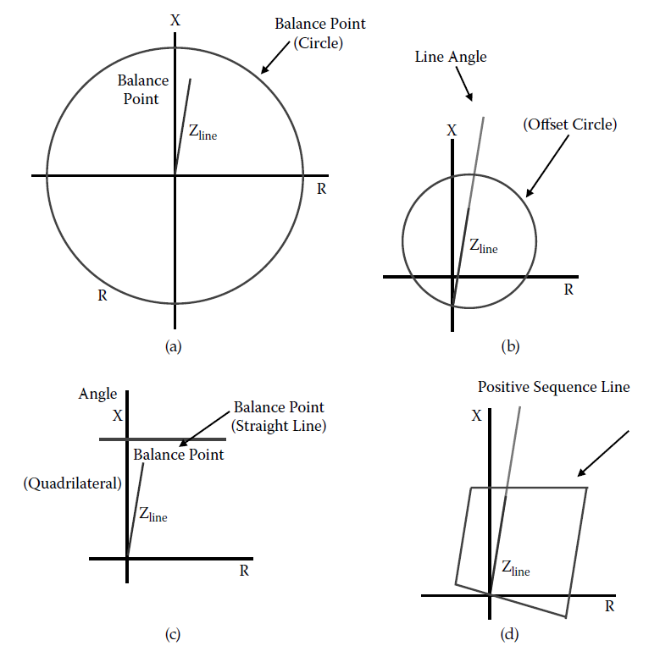
Figure 1: (a) Impedance characteristic; (b) mho characteristic (c) reactance characteristic (d) ground Relay, quadrilateral characteristic.

A distance relay will trip a faulted line almost instantaneously, as long as the fault is within the distance threshold. In order to clear faults outside the distance threshold and also provide backup protection to other parts of the power system, distance relays usually utilize three zones of protection. As shown in Fig.2, Zone 1 is configured so it does not see the remote end of the line and the associated bus, usually configured for up to 80% of the distance and operates instantaneously. In this case the relay is said to be underreaching the remote end. Zone 2 reaches over the remote end, usually the complete line plus 20% of the succeeding line on and is configured to operate with a certain time delay, typically 0.3 to 0.4 seconds. Similarly zone 3 is set in order to provide backup for the protection of the next line and usually extends 120% to 180% of the next line in the busbar and with a time delay of up to 1 second.

3.2.2 Issues with distance relays
As the load on a transmission line increases, the apparent impedance locus approaches the origin of the R-X diagram. For some value of line loading, the apparent impedance will cross into a zone of protection of a relay, and the relay will trip. The value of load MVA at which the relay is on the verge of operation is known as the loadability limit of the relay. This issue is shown in Fig. 3.
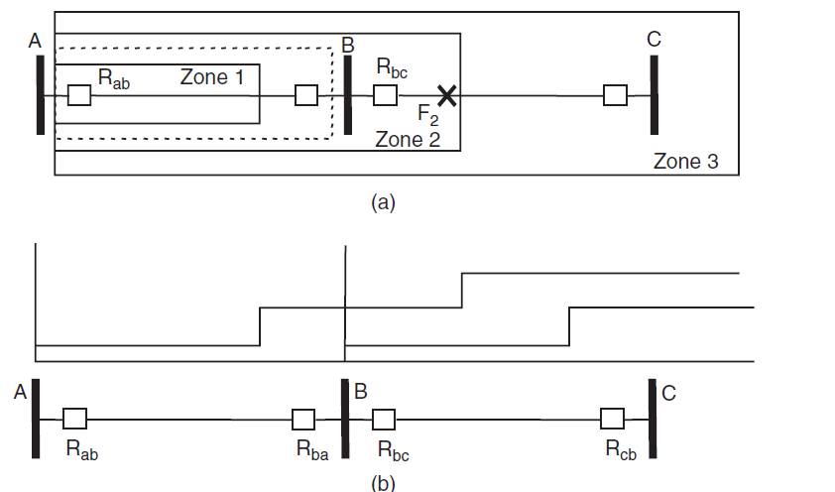
Figure 2: Three-zone step distance relaying to protect 100% of a line, and back up the neighboring line

Series reactors and capacitors affect apparent impedance seen by the relay by introducing a discontinuity in the reactive component and can affect the operation of the distance protection. In the case of series capacitors, distance relays may be made slow enough so that the capacitors are first removed from service by the protective devices, and the proper operation of the distance relays is restored. However, as the series reactors are usually required for achieving safe short-circuit current levels, they are seldom taken out of service without taking the line out of service also. Consequently, the reactor can be considered to be present, and the line relays set accordingly.
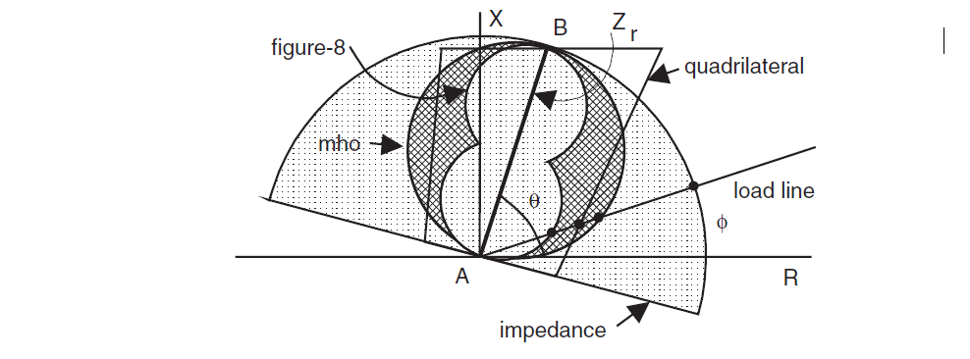
Figure.3. Loadability of distance relays with different characteristic shapes

The impedance of a typical transmission line is highly inductive. Typical impedance phase angles will be in the range of 65-85 degrees, depending on the conductor size, spacing, and bundling. This means that the line impedance characteristic in the complex Z plane, which is inclined at the impedance angle, will usually be oriented as shown in the previous figures. This impedance, however, does not include the impedance of the fault itself, which is typically an arcing resistance. The effect of the arc resistance on distance relaying is to move the end-of-reach impedance to the right in the Z plane, due to the addition of the arc resistance. This effect is shown in Fig. 4. Note that the arc resistance is usually more pronounced at the far end of the reach.

3.3 Bus Protection
The main difference between line and apparatus protection is that the apparatus is physically located at one given point, making it easy to acquire and compare a number of different measurements. However, these devices are more complicated than a transmission line and there are different faults that can possibly appear and for which the apparatus protection should act upon.
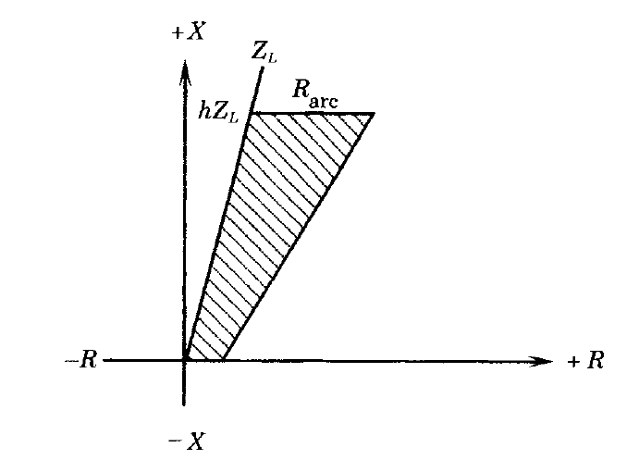
Figure 4: Effect of arc resistance on impedance seen by the relay

In the case of bus protection, if dedicated protection is not used, then the zone 2 protection scheme of the connected transmission line would act when a fault occurs in the bus. However, zone 2 protection is time delayed and this can result in large clearing times for the bus fault. In order to limit the damage caused by a fault in the bus, fast clearing provided by dedicated protection is required.

By far the most common method of bus protection is differential protection. Differential protection functions when the vector difference of two or more similar electrical magnitudes exceeds a predetermined value, with the main concept shown in Fig. 5. Almost any type of relay can function as differential protection, it is not so much the construction of the relay that is important but rather its method of connection in the circuit. Under normal load conditions or when there is a fault outside the protection zone of the element, the secondary currents will circulate between the two CTs and will not flow through the over-current relay. However, if a fault occurs in the section between the two CTs the fault current would flow towards the short-circuit from both sides and the sum of the secondary currents would flow through the differential relay. In all cases the current in the differential relay would be proportional to the vector difference between the currents that enter and leave the protected element; if the current through the differential relay exceeds the setting value then the relay will operate.
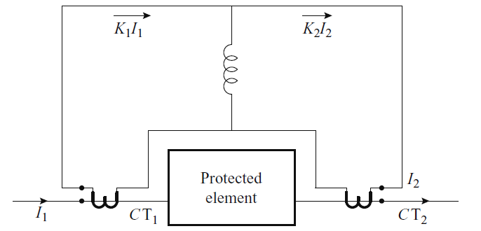
Figure5 : Current balance in a differential protection scheme

The conditions of operation of the differential protection relay for a through fault and a fault inside the zone of protection are shown in Fig. 6 and 7 respectively. In the ideal case the current transformers are assumed identical and to share the burden between the two ends. However in practical applications it is normal to add a resistor is series with the relay to balance the difference created by the unequal nature of the burden between the ends of the two circuits.

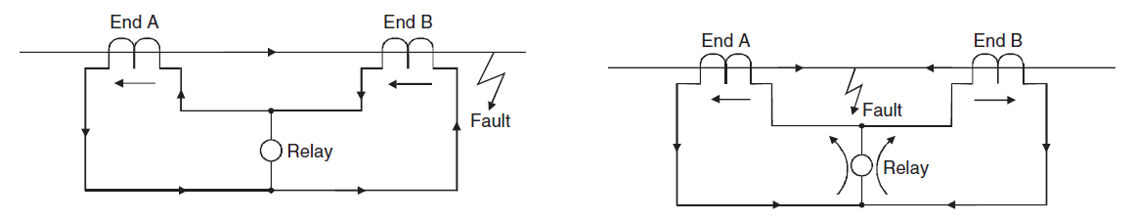
Figure 6: External Fault (the relay does not trip) Figure 7: Internal Fault (the relay trips)

One arrangement that is extensively used is the differential relay with a variable percentage characteristic, alternatively described as being percentage biased. This relay configuration has an additional unit, the restraining coil, in addition to the operating coil and the total ampere-turns are equal to I1xN/2 plus I2xN/2, which is the same as if (I1 + I2)/2 flowed through all of the restraining coil. The relay restraining force increases with the magnitude of (I1 + I2), thus preventing unnecessary tripping due to any CT unbalance errors. In addition, the restraining torque is increased in the presence of through-fault currents producing a more stable operating characteristic and preventing improper relay operation. This configuration is shown in Fig. 8.
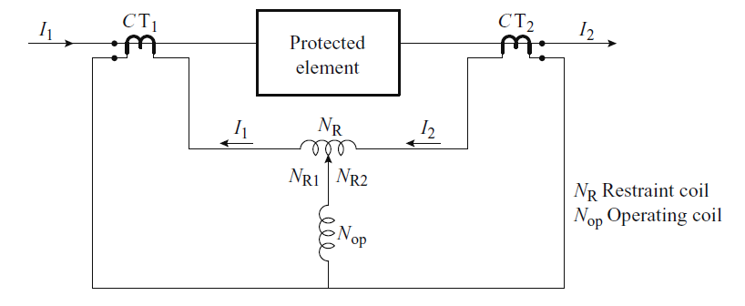

Figure 8: Differential relay with variable-percentage characteristic

Differential relays can be used for power system elements that have more than two terminals. Each of the restraining coils has the same number of turns and each coil produces a restraint that is independent of the others. These add arithmetically. The slope of the operating characteristic of each relay varies depending on the current distribution in the three restraining coils.

Under normal system conditions, in a bus configuration, the power that enters a busbar is identical to the power that leaves. A fault inside the differential circuit unbalances the system and current thus flows in the operating coil of the relay, which then results in the tripping of all the breakers associated with that busbar. In busbar differential schemes that involve bushing type CTs, six to eight secondaries can usually be connected in parallel without difficulty. Although some busbar differential protection schemes still use multiple restraint features, high impedance relays predominate because of their better performance.
3.4 High Impedance Differential protection
The high impedance arrangement tends to force any incorrect differential current to flow through the CTs instead of through the operating coil of the relay, and thus avoids improper operation for external fault or overload conditions when the secondary currents of all the CTs are not the same because of differences in the magnetization characteristics.

This type of bus protection is particularly well suited for situations where a large number of circuits are connected to the bus. The essential requirements for proper application of this principle are the following (a) Equal current transformer ratios on all connections, (b) Low current transformer secondary winding resistance, (c) Adequate knee-point voltage output from the current transformers. (d) Low burden from connecting leads. Using common buses for each phase, balanced groups of CTs are formed in each one of the phases, using a common bus to feed three elements of a high impedance differential relay as illustrated in Fig.9, so that so that the busbar is protected against both phase and earth faults.
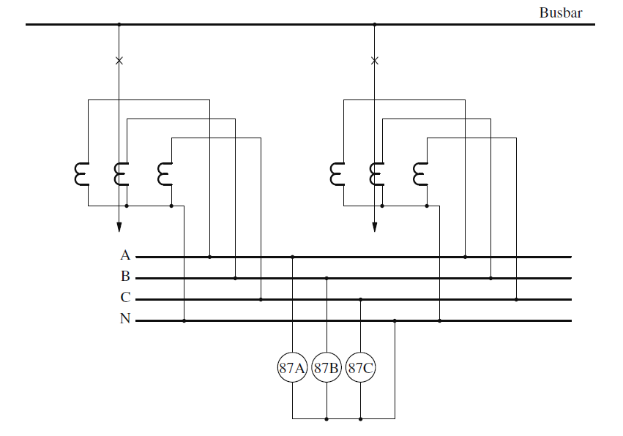
Figure 9: High impedance differential protection arrangement using a common bus for each phase

3.5 Transformer Faults
Faults on transformers are separated in external and internal faults. External faults are those faults or hazards that occur outside the transformer and include
- Overloads that cause the transformer to overheat and have the potential to cause permanent damage or loss of life to the unit. The time constant for overheating is long, however, and it may take many hours of exposure for the condition to become serious.
- Over-voltages that can be either due to short-term transient conditions or long term power-frequency conditions. Transient over-voltages cause end-tum stresses and possible breakdown.
- Under-frequencies that are also caused by a major system disturbance that causes an imbalance between generation and load. The condition is similar to over-voltage in that exciting current is greatly increased at low frequencies, causing over-fluxing of the transformer iron circuits.
- Short circuits that are external to the transformer protection zone, but cause high transformer currents and can cause transformer winding damage.

Internal faults are faults that occur within the transformer protection zone. This classification includes not only faults within the transformer enclosure but also external faults that occur inside the transformer CT locations. These include faults that usually develop slowly such as:
- Overheating that may be due to several different internal transformer conditions such as poor internal connections in either the electric or the magnetic circuits, loss of coolant due to leakage, blockage of coolant flow and loss of fans or pumps that are designed to provide cooling.
- Over-fluxing that may gradually lead to insulation breakdown of the magnetic circuit insulating materials or the electric circuit insulation.
- Overpressure in the transformer tank occurs due to the release of gases or products that accompany the localized heating due to any cause. For example, a turn-to-turn fault may burn slowly or local hot-spots, releasing gases in the process.

Internal faults also include active faults that occur suddenly and usually require the operation of protective equipment in order to disconnect the transformer from the system and limit further damage. Cases of active faults are:
- Short circuits in wye-connected of wye-delta transformers. In this case the fault currents are substantially different at the two windings of the transformer. Also faults that happen very close to the star point of the wye side are very hard to detect from the delta side and because the impedance on the wye side is not a linear function of the number of turns due to increased leakage.
- Short circuits in delta-connected windings where the impedance is smaller than in the wye case and the fault is supplied by two phases, further reducing the amplitude of the fault current.
- Phase-to-phase short circuits in three-phase transformers that result in significantly large fault currents.
- Turn-to-turn short circuits in transformer windings, especially on the HV side of large transformers due to traveling waves because of impulses (either lightning or switching) in the lines.
- Core Faults due to the deterioration of the insulation between the core laminations.
- Tank Faults and Bushing flash-overs.

3.6 Transformer Differential Protection
In order to apply the principles of differential protection to three-phase transformers, the following factors should be taken into account:
- Transformation ratio: The nominal currents in the primary and secondary sides of the transformer vary in inverse ratio to the corresponding voltages. This should be compensated for by using different transformation ratios for the CTs on the primary and secondary sides of the transformer.
- Transformer connections: When a transformer is connected in star/delta, the secondary current has a phase shift of a multiple of 30 degrees relative to the primary, depending on the vector group. This shift can be offset by suitable secondary CT connections. Furthermore, the zero-sequence current that flows in the star side of the transformer will not induce current in the delta winding on the other side. The zero-sequence current can therefore be eliminated from the star side by connecting the CTs in delta. For the same reason, the CTs on the delta side of the transformer should be connected in star. When CTs are connected in delta, their nominal secondary values should be multiplied by 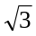so that the currents flowing in the delta are balanced by the secondary currents of the CTs connected in star.
- Tap changer: If the transformer has the benefit of a tap changer it is possible to vary its transformation ratio, and any differential protection system should be able to cope with this variation. Since it is not practical to vary the CT transformation ratios, the differential protection should have a suitable tolerance range in order to be able to modify the sensitivity of its response of operation. For this reason it is necessary to include some form of biasing in the protection system together with some identifying markings of the higher current input terminals.
- Magnetisation inrush: This phenomenon occurs when a transformer is energised, or when the primary voltage returns to its normal value after the clearance of an external fault. The magnetising inrush produces a current flow into the primary winding that does not have any equivalent in the secondary winding. The net effect is thus similar to the situation when there is an internal fault on the transformer. Since the differential relay sees the magnetising current as an internal fault, it is necessary to have some method of distinguishing between the magnetising current and the fault current. These methods include
- Using a differential relay with a suitable sensitivity to cope with the magnetising current, usually obtained by a unit that introduces a time delay to cover the period of the initial inrush peak.
- Using a harmonic-restraint unit, or a supervisory unit, in conjunction with a differential unit.
- Inhibiting the differential relay during the energising of the transformer.

A number of these problems such as the CT ratio, vector compensation and ratio correction is easily performed through interposing CTs as shown in Fig. 10
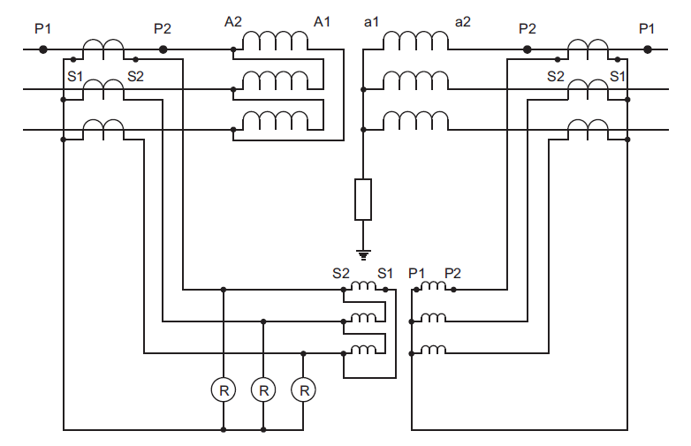
Figure 10: Interposing CT

The transformer differential relay characteristics for a variable restraint-type relay are given in Fig.11. Relay restraint can be varied from 10% to 40% in 5% steps. Current input taps can be varied from 1A to 10A in 0.1A increments. The relay can carry a maximum of 10A in its coils. Minimum relay operate current is 0.5A.

The setting of the slope of differential relays is carried out with the aim of ensuring that there will be no improper operations because of differences in the currents in the restraint windings due to the transformation ratios of the CTs and the operation of the tap changer under load conditions. In order to determine the slope, the restraint and operating torques are calculated on the basis of the currents and the number of turns in the respective coils. In order for the relay to operate the currents should satisfy the following equation.
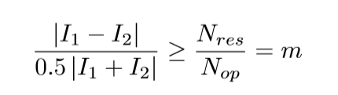
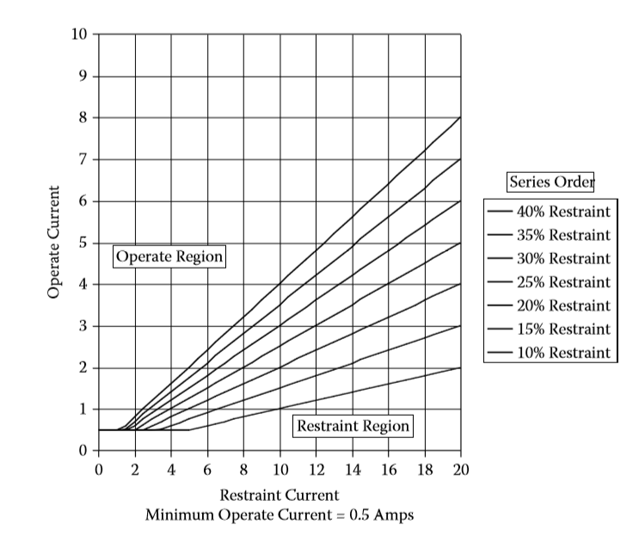
Figure 11: Transformer differential relay characteristic

3.7 Prelab
To help you better understand the lab3 please complete the prelab3 questions on the Canvas before your lab session.

3.8 Laboratory Work
3.8.1 Distance Protection
Fig.12 shows a one-line diagram that should be set up on the Power System Simulator. Line 4, together with the impedance of the grid transformer represents the source impedance. The line to be protected is the ﬁrst section line 6 (0.2pu).
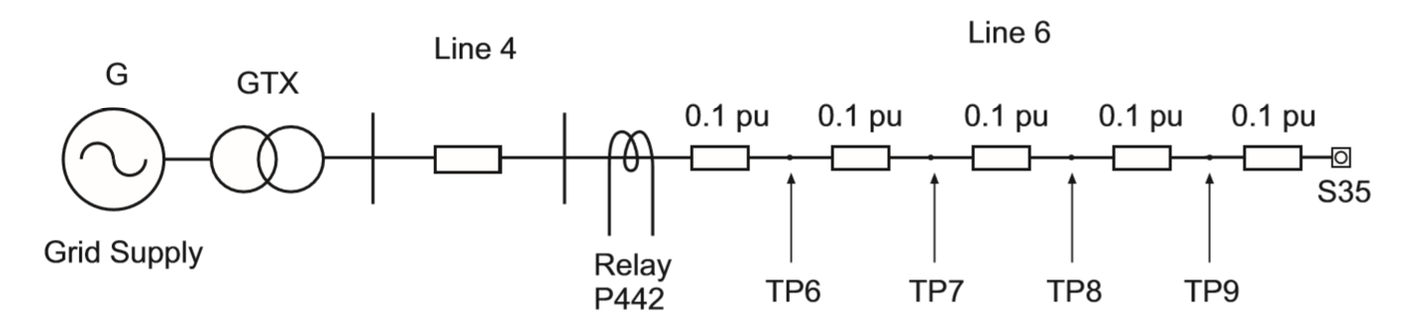
Figure 12: One-line diagram of the three-zone distance protection scheme

Micom P442 is used for the distance protection in the experimental system. Verify that the settings given below have been applied to the distance relay protection. The approximate length of line 6 is 100km with the impedance of 4.8Ω. Therefore in the Group 1 settings, the zone 1 impedance is 3.84 Ω which is 80% of the line impedance 4.8Ω. As a quadrilateral characteristics is used, the resistances for a phase (R1Ph) and earth (R1G) fault in the zone1 as well as zone 1 delay time tZ1 are also given in the table. The kZ1 is the residual compensation factor for the zone 1, which depends on the earthing impedance in the earth fault loops. The corresponding parameters for the zone 2 and 3 in the table below are calculated based on 150% and 220% of line 6.
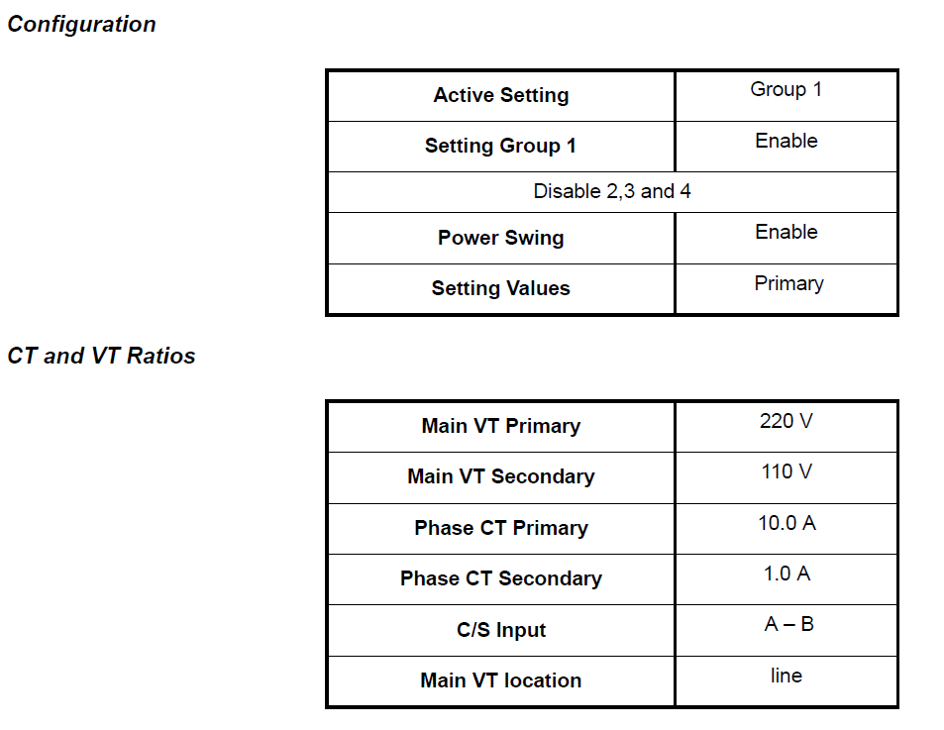
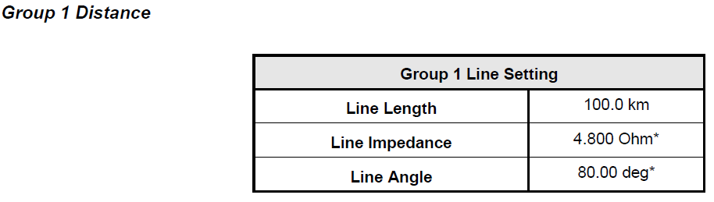
Group 1 Zone Setting
Zone status | 01010
kZ1 Res Comp | 0.5
kZ1 angle | 80 deg
Z1 | 3.840 ohm
R1G | 1.0 ohm
R1Ph | 3.0 ohm
tZ1 | 0.060 s
kZ2 Res Comp | 0.5
kZ2 angle | 80 deg
Z2 | 7.20 ohm
R2G | 2.0 ohm
R2Ph | 5.0 ohm
tZ2 | 0.2 s
kZ3/4 Res Comp | 1.00
kZ3/4 angle | 0 deg
Z3 | 10.56 ohm
R3G-R4G | 3.0 ohm
R3Ph-R4Ph | 7.0 ohm
tZ3 | 0.4 s
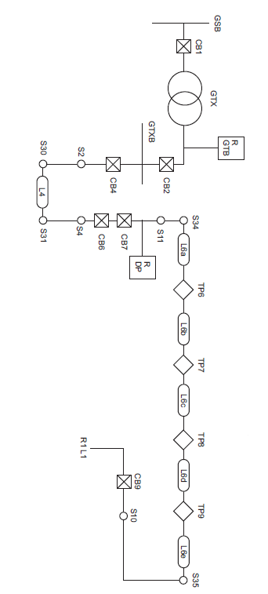
Figure 13. Connection diagram for distance protection
The connection diagram for the system in this part is shown in the Fig.13. Apply a three-phase fault at TP6, between the ﬁrst two 0.10 pu sections of the Line 6. Set time duration for the fault circuit breaker as 0.5s. The relay should operate and the distance to the fault given in the Fault Records of the Menu should be approximately 50km.

Apply three phase faults similarly at TP7, TP8 and TP9. The relay should operate for a fault on TP7 (zone 2), at TP8 (zone 2/zone 3), and at TP9 (zone 3), but not at S35, as it is outside the zone 3 reach. Both the fault distance and fault zone can be found in Fault Records.

For earth faults connect TP7 between one line and earth, via the fault CB, and apply a fault of a phase to earth. The relay should operate and the fault location should be 100 km of Line 6.

3.8.2 Bus Protection
To ensure the relay tripping stability for through faults in differential protection, a high impedance relay rather than relay restraint coils is used. The stabilizing resistor of the bus bar protection relays of the PSS has been set to180Ω. Calculations using the equation:
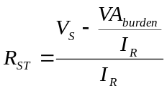
where the Vs is relay tripping voltage; If the CT knee voltage VK, is 81 V, the minimum tripping voltage Vs is assumed equal to VR (voltage across R_{ST} ) and to VK/2. With the relay tripping current I_{R} of 0.20 A and the relay burden is 1VA, the stabilizing resistor is 178 Ω. The maximum available value of this resistor is 220 Ω. A the resistor required is greater than 220 Ω at setting currents much lower than 0.20 A.

Two test points are available for applying faults to the two sections of the main busbar: TP13 and TP14. Sketch the busbar diagram, zones of protection and the position of the test points within the busbar system. Which zone is expected to operate for fault at the available test points? Apply phase-phase (not phase-phase-phase) faults via the test inductor XL (9.6 Ω) and the timed circuit breaker set at 0.3 seconds to the available points.

The relays should not operate for through faults, and is very unlikely in this system even if the setting current is very low. Through current means in at one feeder and out at either another feeder in the same zone, or through the bus section CB (CB10). Zone 1 and Zone 2 include the reserve bus (or back bus), provided the bus section CB (CB15) in the reserve bus is open. If CB15 is closed, current can ﬂow into one zone and out at the other zone, so that both zone relays would trip, illustrating the purpose of the bus section CTs.

Conﬁgure a simple radial transmission and distribution system based on transmission line 2 and the loads at the distribution but to investigate the operation of the protection scheme. Refer Fig.14 for system connections of this part.
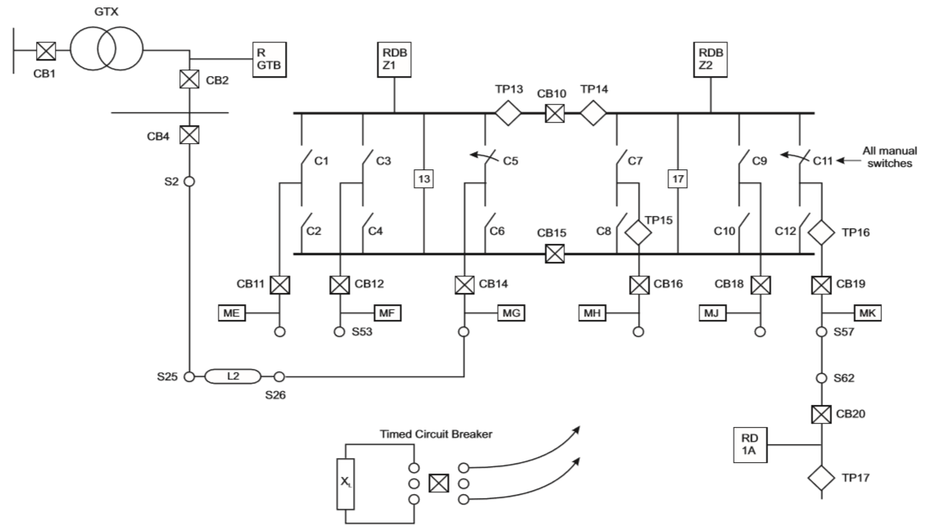
Figure 14. Connection diagram for busbar protection
3.8.3 Transformer Protection
The grid transformer is protected by the relay Micom P632, which provides a number of protections: differential (DIFF), overcurrent (IDMT1), standby (IDMT2), and restricted earth (REF2). DIFF – differential, protects the line faults of external and internal of the transformer. REF2 – restricted earth fault, protects earth faults; IDMT2 is for standby earth fault protection on the secondary of transformer, and IDMT1 is for overcurrent back-up protection on the primary of the transformer. Refer Fig. 15 for the system connection for the grid transformer protection. The fault CB should be set as 0.25s for all the experiments in this part. 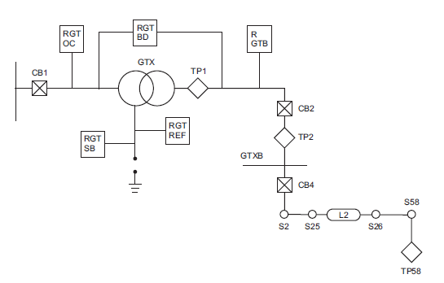
Figure 15: Connection diagram for grid transformer protection
Fig. 16 shows the conﬁguration menu for the P632 diﬀerential relay. The items with a tick are the “enabled settings”. The Table 6 illustrates detailed parameter settings for each enabled item. Note, as the relay only accepts a reference power, S_{ref}, of 100 kVA or over, “artificial” values of S_{ref} (0.4MVA) and Va (0.4kV) and Vb (0.2kV) are used in the Table. Consequently the CT ratios are 1000/1 and 700/1, instead of 10/1 and 7/1. The amplitude matching factor k_{am,a} and k_{am,b}, which remove dependence on the nominal currents of the transformer, are calculated based on them. The ‘vector group matching’ is to bring the primary and secondary relay currents ‘into phase’. The ‘zero-sequence current filtering’ eliminates the zero-sequence currents from three phase currents to avoid undesirable differential tripping. The parameters m1 and m2 in the table, define the tripping characteristics of the differential protection, as shown in Fig.11, in which the threshold value of a transformer differential protection device is not implemented as a constant differential current threshold, but is formed as a function of the restraining current (depending on magnetising current, unbalanced CTs and on-load tap-changers). PS1 refers to the parameter subset 1 in the relay settings. Verify that the settings shown in Table 6 are valid for the conﬁguration. Do the settings for the relay look correct?
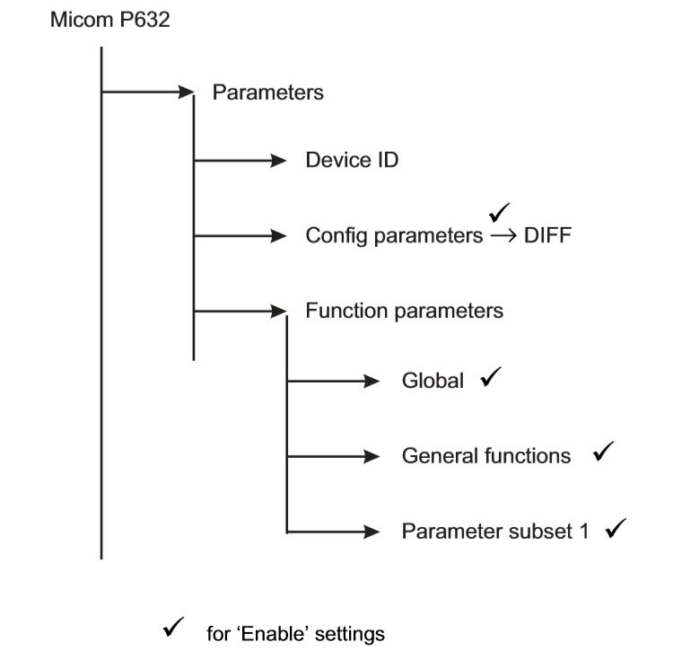
Figure 16. Setting Menu for the Micom P632 biased differential relay

Table 6 Settings of Relay P632
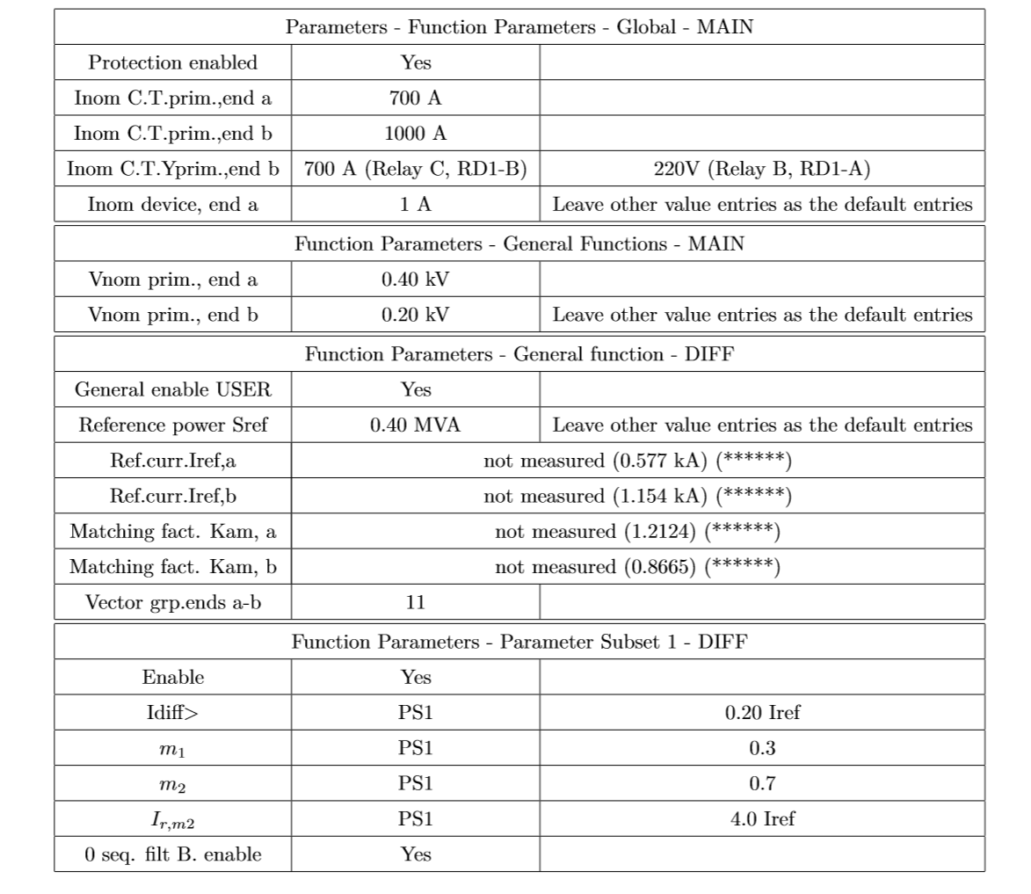
DIFF - Phase to phase fault at TP1: Conﬁgure the timed fault circuit breaker in the Fig. 17 (a). Remove the bridging links from the outgoing terminals of the fault CB. Insert the XL of 9.6 Ω inductor to limit short circuit current. Connect TP1 on the GTX to the fault CB. It might be necessary to inhibit both the restricted earth fault protection and the standby relay for this experiment. In other words, block the relay “restricted earth fault” and “standby earth fault”. Apply a phase-phase fault at TP1. The differential relay of the grid transformer should trip. Record the operating times of the relay and fault currents. Note: the fault connection on TP1 has to be arranged when the PSS is de-energised.
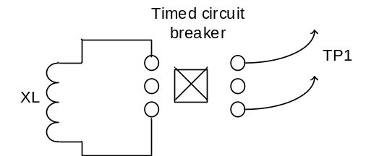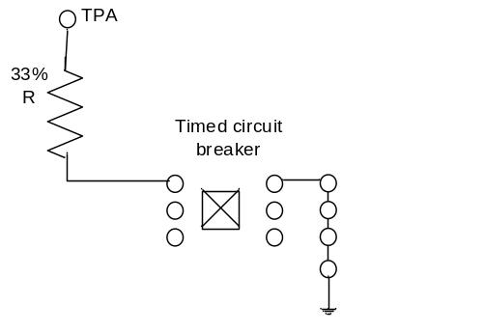

Figure 17 (a) Figure 17 (b)
DIFF - Earth fault on the star winding: Apart from protecting the phase faults of the external of the transformer, the DIFF can also protects earth faults on the internal of the transformer. The proportion of the winding to be protected depends on the earthing resistor R connected with the transformer. The star winding of the grid transformer has two tapping points at which earth faults can be connected: TAP A (20% winding) and TAP B (40% winding) measured from the star point. With the nominal tripping current of 20%, the R calculated for DIFF tripping are:
- For the earth fault at 20% of the winding, Tap A; R≤1.35Ω
- For the earth fault at 40% of the winding, Tap B; R≤5.41Ω.

Conﬁgure a single phase to earth winding fault on the phase A (red) by the fault CB terminal. TAP A (20% winding) using the TPA terminal point in the test point center panel via 33%R (in test point center panel, about 3Ω) to limit short circuit current, shown as Fig. 17 (b). You may block the “Standby” and REF2 protection for this test. Set up the time for fault circuit breaker as 0.25s. Does the DIFF trip? Why? Connect TPB (40% winding) on the GTX to the fault CB via the fault resistor 33%R and repeat. Does the DIFF trip this time? Record the fault currents and tripping time.

Restricted Earth Fault Protection –REF2:
It was observed from the previous experiment that the diﬀerential protection of the transformer does not operate properly for earth faults at the 20% winding tap. To protect a greater percentage of the winding than is possible with differential protection, restricted earth-fault protection is used. For an internal fault on the transformer winding the Restricted Earth fault element of the relay may be tripped by a relay current produced only by the 7/1 CT in the earth connection of the star-connected secondary winding, as shown in Fig.18 as no currents produced from the line CTs and only earth connection CT is energised. Note the restricted earth fault protection should be un-blocked but still the standby relay remains inhibited. Set up the time for fault circuit breaker as 0.25s.

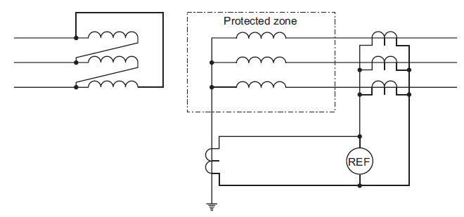
Figure 18. Star winding restricted earth-fault protection

With the earth tripping current settings of 20%, the resistance calculated to achieve the tripping current at TAP A and TAP B are 11Ω and 22Ω, respectively. In other words, REF2 will be tripped
- R≤11Ω for an earth fault occur at TAP A (20% winding)
- R≤22Ω for an earth fault occur at TAP B (40% winding).
The grid transformer has four possible earthing resistors: TAP1 - 9.8Ω, TAP2 – 12.7Ω, TAP3 – 21.2Ω, and TAP4 – 25.5Ω, which are below and above the two values. Using the earthing resistors to set up an earth fault at TAP A and TAP B as below:
- Apply a phase to earth fault to TAP A via TAP1=9.8Ω. Repeat it at TAP B;
- Apply a phase to earth fault to TAP A via TAP2=12.7Ω. Repeat it at TAP B;
Observe the earth-fault current values for which the restricted earth fault protection operates. Do not use the 9.6 Ω inductor in the earth connection.

If the diﬀerential and restricted earth fault relays do not operate, the standby relay should operate, but the operation time of backup and unrestricted relays are large, practically in the range of 10 seconds.

Appendix C - Use of the PSS Protection Relays
The PSS1 uses industry standard MiCOM numerical protection relays (manufactured by Areva). These relays are equipped with microprocessors that do various signal analysis and protection functions in the one box. They are designed to be set either manually via a menu, or by downloaded set points from a lap-top computer (typically the latter in real life). In the power systems lab, the manual menu input and input from the PSS1 PC via the front portal can be used. The menu is logically arranged and very extensive. However, only a small sub-set of the relay capabilities are needed for the laboratory experiments. The main ones are summarized below.

The relay front panels for the P142 and P632 relays are shown in Figs. 33 and 34.

There are four LEDs on the left-hand side of the panel – Green meaning healthy and in operation,Yellow meaning out of service, Flashing Yellow meaning that the relay has registered an alarm, which means that the relay will not operate normally until the alarms have been cleared and Red indicating that a trip has been issued by the relay. It has to be reset before further use by the Clear (C) button on the relay and the Reset button on the PSS center panel.

The relay’s menu is arranged in a tabular fashion. The top row of each column in the menu structure describes the settings within that column. You move from column to column by the left and right arrow keys. You move up and down within a particular column by using the up and down arrow keys (see Fig 33). The menu structures vary from relay to relay. The menu structures for the P142 relay is shown in Fig 35.

Measurements (Volts, Amps, etc):
Navigate around the top level menu by the left/right arrow keys. Basic data such as time, frequency, volts and amps will be displayed. If a trip or alarm has been received, press the Read button (little book icon). All relevant data can be read, such as relay current, trip time, CB operating time, etc.

To enter the lower menu tree, press the down arrow key (P142) or Enter key (P632) and then the left/right arrow keys, to view event and fault records, and disturbance records and measurements (under Column 2 View Records in P142 or under the Events column in P632).

Conﬁrming/Altering Settings in the Relays:
For the P142, press the down arrow key and then the left/right arrow keys and select the column Parameters. Then press the down arrow and select sub-set Function Parameters. Then move the subheading Global and then Main for CT ratio details; up to Function Parameters then General Functions then Main for input and output side voltages; then up to Function Parameters again, then General Functions then DIFF for the reference power and vector group; then up to Function Parameters again, then Parameter Subset 1 then DIFF for the diﬀerential current. All settings will be displayed. To alter a setting, press the enter key, alter the values with the down/up keys, then the enter key again to conﬁrm the new settings.

If a password is requested at any stage by a relay, enter the factory default AAAA (“on the relay keypad ↑→↑→↑→↑”) then press Enter.

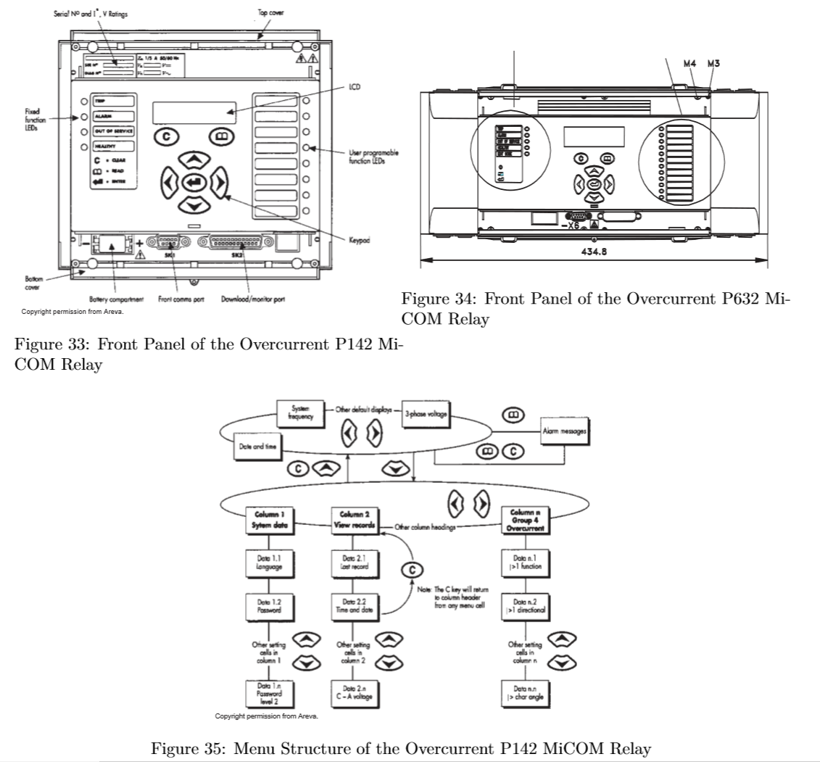

Reading Fault Records from a Relay Front Panel:
When a relay trips, alarm messages will be indicated by the default display on the relay screen and by the yellow alarm LED ﬂashing. The alarm messages can either be self-resetting or latched, in which case they must be cleared manually. To view the alarm message press the read key. When all alarms have been viewed, but not cleared, the alarm LED will change from ﬂashing to constant illumination and the latest fault record will be displayed (if there is one). To scroll through the pages of this record, use the read key. When all pages of the fault record have been viewed, the following prompt will appear:
“Press Clear to reset alarms”
To clear all alarm messages press C; to return to the alarm/faults present display and leave the alarms uncleared, press the read key. Depending on the password conﬁguration settings, it may be necessary to enter a password before the alarm messages can be cleared (see section on password entry). When the alarms have been cleared the yellow alarm LED will extinguish.

Alternatively it is possible to accelerate the procedure. Once the alarm viewer has been entered using the read key, the C key can be pressed, this will move the display straight to the fault record. Pressing C again will move straight to the alarm reset prompt, where pressing C once more will clear all alarms.

Changing Settings from the Front Panel:
To change the value of a setting, ﬁrst navigate the menu to display the relevant cell. To change the cell value press the enter key ← -, which will bring up a ﬂashing cursor on the LCD screen to indicate that the value can be changed. This will only happen if the appropriate password has been entered, otherwise the prompt to enter a password will appear. The setting value can then be changed by pressing the ⇑ or ⇓ keys. If the setting to be changed is a binary value or a text string, the required bit or character to be changed must ﬁrst be selected using the ⇐ and ⇒ keys. When the desired new value has been reached it is conﬁrmed as the new setting value by pressing ← -. Alternatively, the new value will be discarded either if the clear button C is pressed or if the menu time-out occurs.

For protection group settings and disturbance recorder settings, the changes must be conﬁrmed before they are used by the relay. To do this, when all required changes have been entered, return to the column heading level and press the key. Prior to returning to the default display the following prompt will be given: ’Update settings? Enter or clear’

Pressing ← - will result in the new settings being adopted; pressing C will cause the relay to discard the newly entered values. It should be noted that, the setting values will also be discarded if the menu time out occurs before the setting changes have been conﬁrmed. Control and support settings will be updated immediately after they are entered, without ’Update settings?’ prompt.

